**Patient Information Leaflet**

Brownlow Health is a partnership providing NHS Services under an NHS England Medical Services Contract.

Brownlow Health @ Marybone

2 Vauxhall Road

L8 6SH

Telephone: 0151 330 8200

Website:

marybone.brownlowhealth.co.uk

**GP services are provided   
to the following areas:**

**Opening hours**

|  |  |  |
| --- | --- | --- |
| Monday | 8 am | 6:30 pm |
| Tuesday | 8 am | 6:30 pm |
| Wednesday | 8 am | 6:30 pm |
| Thursday | 8 am | 6:30 pm |
| Friday | 8 am | 6:30 pm |

***Our site is fully accessible.***

**Improved access/Extended hours available on some days. Visit the practice website for further details.**

**Services we provide**

Along with routine appointments, the practice offers the following services:

* **Family planning –** We offer a full range of family planning and baby / post-natal care services
* **Immunisations –** The nursing team administers vaccines for both adult and child immunisations. We hold set vaccination clinics and you will be invited as appropriate.
* **Minor surgery –** Your GP will advise on minor operations
* **Cervical smear testing –** For women aged 25 – 65. These tests are undertaken by the nursing team.
* **Health and Wellbeing Services –** We have Health and Wellbeing coaches as well as Social Prescribers that can support our patients.
* **Chronic disease management –** We hold a range of clinics to help our patients to manage their long-term medical problems including asthma, diabetes, hypertension, kidney disease and heart disease.
* **Other services –** Health checks for adult patients aged 16 to 74 years and 75 years and over are also available especially for those who have not seen a clinician at this practice. Details are available from reception and on the practice website.

We also offer the following services: smoking cessation advice, clinics to support with drug and alcohol addiction.

*From time to time, other services may be available such as raising awareness of a particular disease or condition. We will advertise this information on our website and within the practice.*

**Teaching practice**

The practice is a teaching practice and occasionally trainee clinicians may, as part of their training, be required to sit in with their trainer GP / Nurse during consultations with patients.

You will always be asked if you consent to this prior to your consultation. If you do not consent, the trainee clinician will not sit in on your consultation.

**How to register at the practice**

The quickest way to register at the practice is to use the practice website. If you are unable to use the website, please visit the practice to collect a registration form.

You may be able to register as an out of area patient. You will be required to complete a patient health questionnaire to see if this would be clinically appropriate before your registration is accepted. Please contact us if you need further information.

**Patients’ rights and responsibilities**

When registering, you have a right to express a preference to be seen by a particular GP. This will be recorded on our clinical system and, where possible, you will be allocated appointments with that clinician. All patients will be assigned an accountable GP.

You may also be offered a health check when you join the practice for the first time (see the practice website for a full list of your rights and responsibilities).

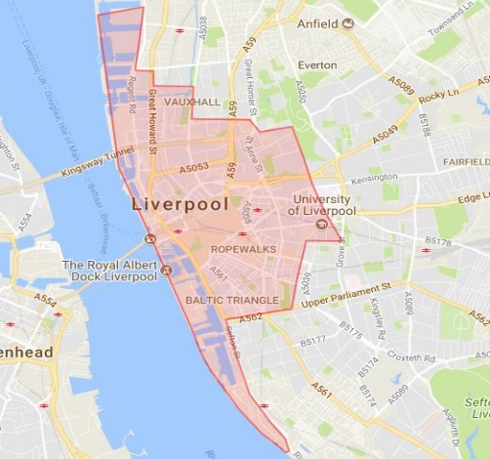

**Further information can be sought from** [**www.nhs.uk**](http://www.nhs.uk)

**Comments, suggestions and complaints**

Comments and suggestions can be raised directly to any staff member.

A complaint can be made verbally or in writing. A complaints form is available from reception. Additionally, you can complain online via the practice website. For further information, please ask for a copy of the practice complaints leaflet.

**Home visits**

Home visits are at the discretion of the GPs and are usually for those patients who are housebound or have significant health issues. Should you require a home visit, please use the practice website or call us to request one. A clinician will then telephone you to discuss your request.

**When we are closed**

When the practice is closed, if you urgently need medical help or advice and it is life threatening, dial 999. If it is not life-threatening, please visit your local walk-in centre, contact NHS 111 by calling 111 or accessing via [www.nhs.uk](http://www.nhs.uk)

**Appointments and accessing practice services**

To make an appointment to see your GP or any member of our healthcare staff or to access any other of our practice services, please visit the practice website to use our online services provided by Blinx. Should you be unable to access the website, please visit the practice or ring 0151 330 8200 and a member of our team will be able to assist you.

The practice website contains all the relevant practice information that you are likely to require.

**Threats of violence or abuse of our staff**

Our staff work hard to provide you with the best possible service. Please treat them with the courtesy and respect they deserve. We operate a zero-tolerance policy and may refuse to provide services to individuals or those accompanying individuals who are abusive, violent, threaten violence, commit or threaten to commit a criminal offence.

Such behaviour may result in removal from the practice list.

**Patient data**

All clinical and administrative staff have an ethical as well as a legal duty to protect patient information from unauthorised disclosure and in accordance with UK GDPR.

The patient privacy notice is available on the practice website.

**The Practice Team**

This practice operates under a partnership agreement and provide services on behalf of the NHS.

**Partners**

* **Dr Ahmed Alimam**
* **Dr Donna Evans**
* **Dr Diane Exley**
* **Dr Deborah Faint**
* **Dr Genevieve Furlong**
* **Dr Stewart Hale**
* **Dr Elizabeth Lynch**
* **Dr Nicki Mazey**
* **Dr Deborah Noland**
* **Dr Ian Pawson**
* **Denise Wilson –** Advanced Nurse Practitioner
* **Tina Atkins –** Management Partner
* **Helen Winsland –** Finance Partner

We have a number of Salaried GPs, Nurses and other healthcare staff working at Brownlow Health, please visit the website for more details.

**Practice Management:**

* **Michelle Cassidy –** Site Manager
* **Sam Green –** Operations Manager
* **Christine Hughes –** Deputy Operations Manager

**NHS England Contact**

Brownlow Health provides NHS services on behalf of NHS England, PO Box 16738, Redditch, B97 9PT.

Telephone: 0300 311 2233

Email: [england.contactus@nhs.net](mailto:england.contactus@nhs.net)

This leaflet was produced from the Patient Information Leaflet Policy

**Prescriptions/repeat prescriptions**

Your GP will initiate any prescription that they determine you require. Repeat prescriptions can be ordered in the following ways:

* In person – By visiting our reception
* By telephone – for housebound and eligible patients only
* Online – Via the NHS or Patient Access app

***Please allow 48 hours for collection (excluding weekends and bank holidays) when ordering repeat prescriptions.***

**NHS App**

We encourage all of our patients to use the NHS app. The NHS App gives you a simple and secure way to access a range of NHS services. You can download the NHS App on your smartphone or tablet via the Google Play or App Store. Alternatively, you can access the same services in a web browser by logging in through the NHS website. To use the NHS App, you must be 13 or over and registered with a GP surgery in England or the Isle of Man.